EXP:7 SELECT with various clause – GROUP BY, HAVING, ORDER BY
Questions:
GROUP BY - HAVING
- How many students are registered for each course? Display the course description and the number of students registered in each course.
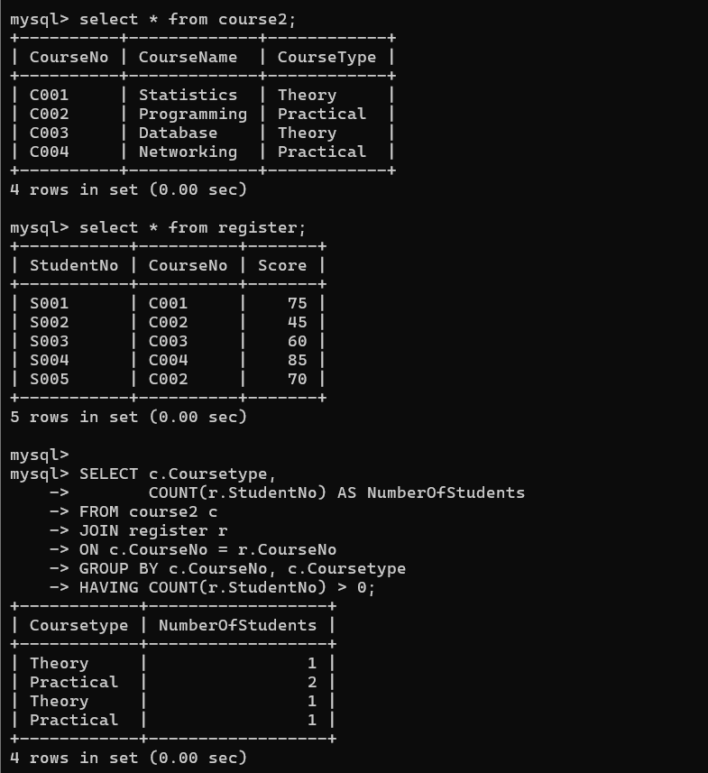
- How many courses did each student register for?
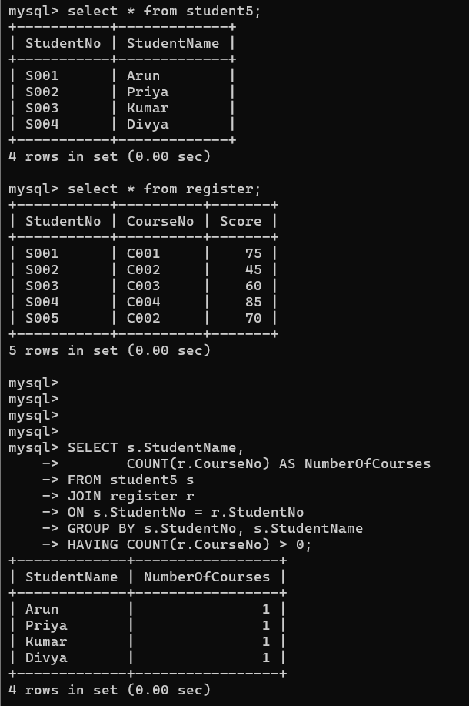

ORDER BY
1. Retrieve Name, Gender, Mobile No of all the students in ascending order of Reg No. 2. List the faculty members in the order of older faculty first.


RESULT:
The records from the tables are displayed using SELECT commands with GROUP BY, HAVING and ORDER BY.

